Assignment 5

ID 38

2017/2/24

4.4

1. The Mean point 171.1 can be a good estimate for average height of active individuals. The median is 170.3
2. The standard deviation is 9.4. The IQR is Q3-Q1 = 177.8-163.8=14
3. No, because its value: . within of the mean.

No, because its value: . within of the mean.

1. No. Different samples will have different point estimates, even if they all approximate the population parameters.
2. I will use SE = to estimate sample’s mean

4.6

1. Binomial distribution
2. Right skewed.
3. I will calculate the variance of this distribution:
4. As the sample size increase, the variability of the new distribution will decrease.

4.8

According to the case, the point estimate of mean is 0.52 and = 0.024. To create a 99% confidence interval for this case, we have

which is (0.4581,0.5819)

We are 99% confident that the fraction of U.S. adult Twitter users who get some news on Twitter is between 45.81% and 58.19%.

4.10

1. False

= less than 50% U.S. adult Twitter users get some news through Twitter ();

= more than 50% U.S. adult Twitter users get some news through Twitter ().

According to the table, its relevant area is 0.2033, which is greater than 0.01. Therefore, we cannot reject

1. False

Such standard error of 2.4% is the standard error of this sample, not the population.

1. False

If we want to reduce the standard error of the estimate, we are supposed to increase the size of sample instead of decreasing.

1. False

90% confidence interval is smaller than 99% confidence interval, because the larger confidence interval is, the wider the interval area it covers.

4.12

1. During the past 30 days U.S. residents’ mental health are not good
2. We are 95% confident that the days that U.S. residents’ mental health are not good is between 3.40 and 4.24 days during the past 30 days.
3. 95% confidence interval is smaller than 99% confidence interval, because the larger confidence interval is, the wider the interval area it covers.
4. Larger. The smaller sample size, the larger standard error.

4.14

1. False

The confidence interval captures the population parameter instead of the point estimate.

1. False

We can ignore this right-skewed distribution when the sample size is fairly large.

1. False

Different sample will have different sample mean.

1. True
2. True
3. False

Margin of error = . With the fixed value, if we want to decrease the margin of error to third of current one, we need to use a sample 9 times larger.

1. True. 89.11-84.71 = 4.4

4.16

The estimate average marriage age and .

Then we compute the , the average age at first marriage of women using a 95% confidence interval is = (23.32,23.56)

We are 95% confident that the average age of first marriage of American women is between 23.32 and 23.56.

Assumption: 1) Normal distribution; 2) Independent sampling; 3) Sample size is greater than 30

4.18

1. There is not a difference in the average calorie intake of a diners at this restaurant. ()

There is a difference in the average calorie intake of a diners at this restaurant. ()

1. The average GRE Verbal Reasoning score has not changed since 2004. ()

The average GRE Verbal Reasoning score has changed since 2004.

()

4.20

According to the interest of this social scientist, she seems to be more care about whether there is any change of the first marriage average age.

Therefore, it should be ,

4.22

1. Unreasonable. Obviously, $100 is far outside of 95% confidence interval.
2. No. 90% confidence interval will have much smaller interval than 95% confidence interval.

4.36

1. Left skewed. Because median > mean;
2. I would expect most student have score above 70. The median is 74 and this distribution is obviously left skewed.
3. Yes. Because the sample is independent and large enough.
4. , According to the table, we know that
5. The standard deviation of the mean will increase when cutting the sample size.

4.40

1. The population SD is known and the data are nearly normal. So it would be normal distribution
2. , . Therefore, the probability that the mean lifespan of 15 randomly chosen light bulbs is more than 10500 hours is

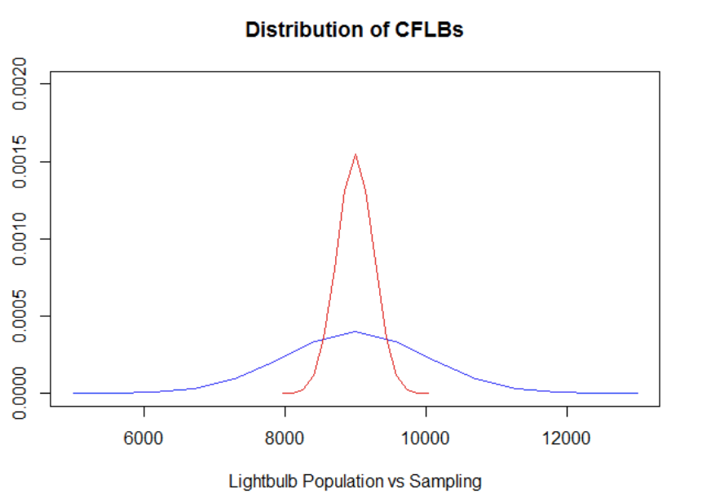

1. No. Without normal population distribution, we cannot estimate (a) or (c).

4.44

1. The probability that the nearsightedness affects all children is not 8%. ()

The probability that the nearsightedness affects all children is NOT 8%. ()

1. Looking up Z value in table, we find
2. Since , we fail to reject .

4.48

With the increase of sample size, the SE will decrease, Z will increase. Therefore p-value will decrease.